Payroll Management System For Information Technology Company

Use-Case-Realization Specification: Delete Feedback

Version 1.0

Revision History

|  |  |  |  |
| --- | --- | --- | --- |
| **Date** | **Version** | **Description** | **Author** |
| 20/12/2019 | 1.0 | Final | Ta Van Hiep |
|  |  |  |  |
|  |  |  |  |
|  |  |  |  |

Table of Contents

1. Introduction 4

1.1 Purpose 4

1.2 Scope 4

1.3 Definitions, Acronyms, and Abbreviations 4

1.4 References 4

1.5 Overview 4

2. Flow of Events—Design 4

2.1 Class Diagrams 4

2.1.1 Top-level class diagram: 4

2.1.2 Detail class diagram: 5

2.2 Sequence diagram 7

3. Derived Requirements 7

Use-Case-Realization Specification: Delete Feedback

# Introduction

## Purpose

This document describes how the Delete Feedback Use-Case is realized within the design model, in terms of collaborating objects

## Scope

This document applies solely to the use case: Delete Feedback which will be developed by JavaTech Group.

## Definitions, Acronyms, and Abbreviations

## References

[1] ***Use-Case Specification: Delete Feedback***, Ta Van Hiep, JavaTech.

## Overview

In the following section, Use-Case Realization Specification of the Delete Feedback Use-Case of the Payroll Management System is provided in detail. This document described by class diagram and sequence diagram that demonstrate the flows realization in further detail. In the last section, the requirements have not been provided in the design model.

# Flow of Events—Design

## Class Diagrams

### Top-level class diagram:

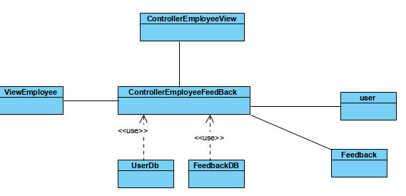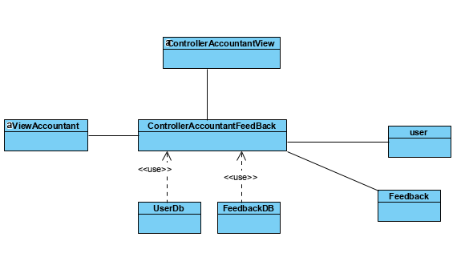

### Detail class diagram:

#### Controller class diagram:

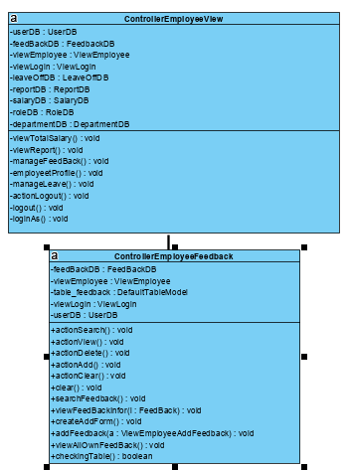

#### Model class diagram:

* Data Access Class

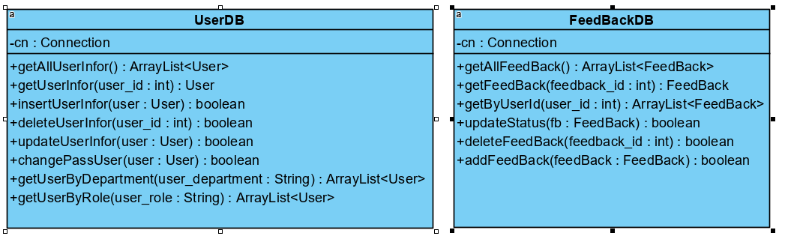

* Entity Class

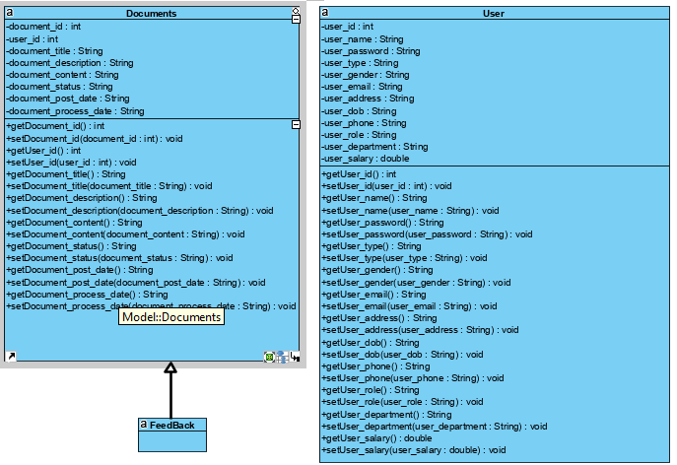

## Sequence diagram

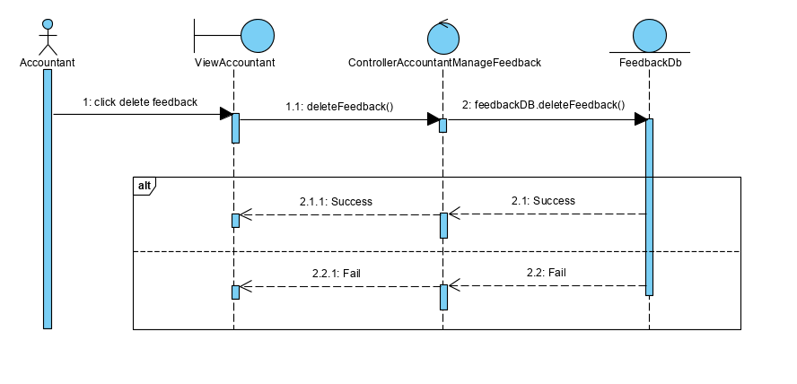

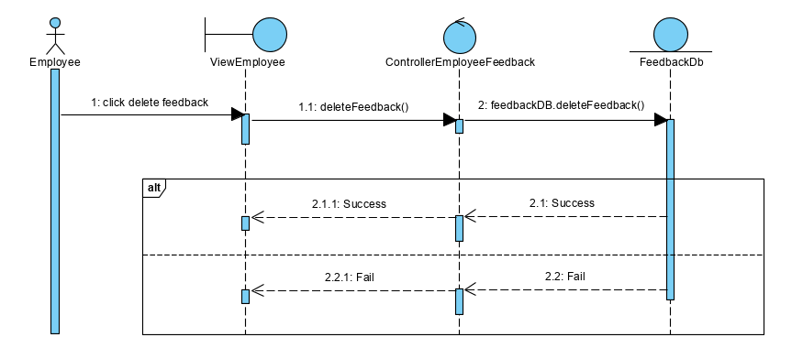

# Derived Requirements

No derived requirements.